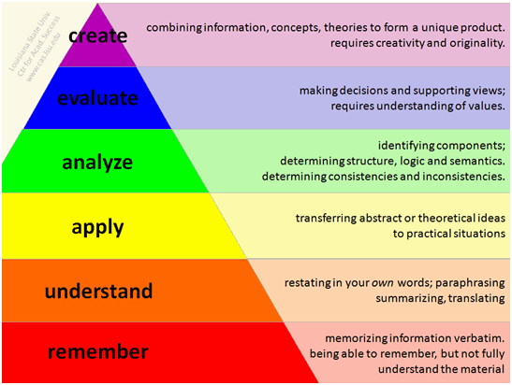

# Revised Bloom’s Taxonomy