Online Resources for Managing Differentiated Classrooms

FOR YOUR TOOL BOX: Select 5 - 10 of the videos below to watch (all of the one-minute videos together count as one). The first video clip and the one titled, “Improving Practice with Sarah Brown Wessling,” are both required viewing for everyone!
Use the following prompts to comment on each of your selections. Copy and paste the links that you use and include them with your comments. Organize this information in a chart or whatever other format that you prefer. [I encourage you to peruse this Teaching Channel website for other ideas applicable to your future classroom.]
PROMPTS to be used for each video viewed:
- Specific Strategy(ies) Demonstrated:
- Potential Value or Application of the Strategies/Ideas in My Future Classroom:
- How the Ideas Demonstrated Might Enhance Differentiated Instruction:

Although the videos feature specific grade levels, subjects or lessons, be analytical in considering the broader applications of the video content.

Great video clips demonstrating various strategies!
https://www.teachingchannel.org/videos/classroom-management-during-centers?fd=1
Play next
- 14 min

Classroom Management during Centers
Grade K / Math / Centers
Resume Video

- 14 min

Strategies to Improve Transitions and Time Management
Grades 6-8 / ELA / Procedures
________________________________________________________________________
- 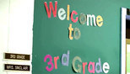14 min

Caring and Control Create a Safe, Positive Classroom
Grade 3 / ELA / Management
_________________________________________________________________________
- 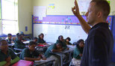1 min

Attention Getting Signals: One Spot
- 1 min

Sprinkles: Pass the Clap

- 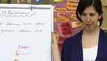5 min

Ms. Noonan: Managing Transitions
- 3 min

Welcome to Teaching Channel!5 min

Lesson Ideas

Passing Notes to Exchange Ideas
Grades 6–8 / ELA / Interaction
6 min
_____________________________________________________________________________________

Lesson Idea (Common Core)

Silent Tea Party: Pre-Reading for Challenging Texts
Grades 9-12 / ELA / Literature
5 min
___________________________________________________________________________________

Lesson Idea (Common Core)

Differentiating with Learning Menus
Grade 7 / Social Studies / Differentiation
5 min
_____________________________________________________________________________________

Lesson Idea (Common Core)

Socratic Seminar: Supporting Claims and Counterclaims
Grades 9-12 / ELA / Debate
5 min
_____________________________________________________________________________________

Teaching Practice

Improving Practice with Sarah Brown Wessling
All Grades / All Subjects / Lesson Planning
28 min
_____________________________________________________________________________________

Teaching Practice

Guided Reading with Jenna Complete Lesson
Grade 5 / ELA / Differentiation
34 min

_____________________________________________________________________________________
- 5 min

Kick Me: Making Vocabulary Interactive
Grade 7 / ELA / Writing

Lesson Objective
Students find missing words from classmates to complete analogies
Common Core Standards: ELA.L.7.5b

- 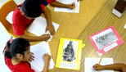6 min

Gallery Walk
Grades 3-5 / All Subjects / Interaction
________________________________________________________________________

- 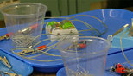7 min

Magnets: Teach From the Heart
Grades 3-5 / Science / Magnets
________________________________________________________________________

- 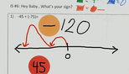5 min

What's Your Sign: Integer Addition
Grade 7 / Math / Number Sense

